**IdentIT: Part of The Cronos Group**

The Cronos Group is recognized as one of the largest IT service providers in Belgium, renowned for its extensive ecosystem and commitment to innovation. With more than 9,000 employees, the Cronos Group operates over 600 competence centers, creating a robust network of expertise across various domains.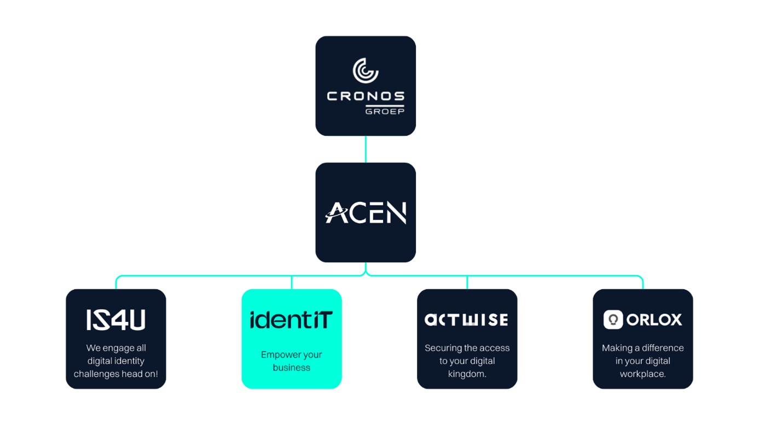

In today’s digital landscape, Identity & Access Management is essential for building a successful digital-first strategy. IdentIT’s mission is to deliver cutting-edge (C)IAM solutions that enhance customer experience, strengthen security measures, drive cost efficiency, increase business flexibility, and ensure compliance with data protection regulations.

**INTERNSHIP**

**Access Manager the DevOps Way**

**Description of Assignment**

During this internship, you will set up and automate Curity (an Access Management tool) in a scalable infrastructure. The focus is on deploying the tool in a DevOps manner across multiple environments: test, acceptance, and production. Redundancy will be provided by running multiple instances per environment, spread across virtual machines or within a Kubernetes cluster.

**What will you do?**

* Design a deployment strategy that can be VM-based or Kubernetes-based
* Automate installation and configuration via CI/CD pipelines (e.g., GitHub Actions, GitLab CI, Azure DevOps)
* Ensure redundancy and availability within each environment
* Integrate Curity with different authentication methods in an end application
* Document the process and deliver a reusable setup

**What will you learn (technical)?**

* Working with DevOps tools and principles, including applying automation and continuous integration
* Applying Infrastructure-as-Code with tools such as Terraform, Helm, Ansible, and Git
* Provisioning and managing Kubernetes clusters and/or virtual machines
* Setting up and managing CI/CD pipelines for efficient software delivery
* Integrating Curity with an end application

**Which soft skills will you develop?**

* Communication skills: reporting and documenting clearly and professionally, and collaborating with colleagues and stakeholders
* Teamwork: functioning effectively within a multidisciplinary team in an agile environment
* Problem-solving: analyzing technical challenges and resolving them independently or in consultation
* Self-organization: taking responsibility for your tasks, planning, and progress
* Critical thinking: substantiating choices and continuously improving based on feedback and evaluation
* Customer focus: considering user needs and business context when designing solutions

**Project Methodology**

* The internship assignments follow the Scrum project methodology to ensure a structured and efficient approach to (sub)tasks.
* This reflects IdentIT’s project approach.
* Scrum is a flexible framework that:
  + Promotes collaboration
  + Encourages adaptability
  + Ensures transparency
* The work is organized into time-boxed iterations called sprints:
  + Each sprint lasts 2 to 3 weeks
  + Each sprint has clear objectives and tasks
* At the start of each sprint:
  + Intern(s) and supervisor(s) hold a sprint planning session
  + Objectives are defined
  + A sprint backlog is created
* During the sprint:
  + Weekly stand-up meetings take place
  + Progress is discussed
  + Potential obstacles are identified and addressed
* At the end of each sprint:
  + A sprint review is conducted
  + If possible, a demo is given
  + Feedback is collected
* Scrum contributes to a collaborative and adaptable work environment.
* The goal is to achieve the best possible results within the given timeframe.

**MVP**

The minimum feature set we expect is:

* Final application (in 3 environments) integrated with Curity and supporting different authentication methods (such as username/password, MFA, etc.)
* Three environments (test, acceptance, and production) where configuration can be “promoted” between environments

**Expected Outcomes**

At the end of the assignment, the following outcomes are expected:

* (Technical) analysis of the problem statement
* Architecture of the required components
* The MVP and possible extensions
* Demo of the DevOps integration/functionality
* Documentation

**Contact details**

**Contact Person**

Cindy Van den Hoecke ([Cindy.vandenhoecke@acen.eu](mailto:Cindy.vandenhoecke@acen.eu))